Dated <<Signing Date>> Apr, 2015

between

ST Electronics (Info-Software Systems) Pte Ltd.

and

**i2s Business Solutions Pte Ltd**

**Business Process Management Suite (BPMS)**

**STATEMENT OF WORK**

**Parties**

1. **ST Electronics (Info-Software Systems) Pte Ltd**, a company having its registered at 1 Ang Mo Kio Electronics Park Road #04-01 Engineering Hub, Singapore 567710 (“**ST Electronics** ”);
2. **i2s Business Solutions Pte Ltd (**Company No.200412802C), a company incorporated in Singapore and having its registered address at 64 Cecil Street, Singapore 049711 (“**i2s**”).

This is a Statement of Work under, and forming part of, the Professional Services Agreement between the parties dated <<Signing date>> Apr, 2015.

|  |  |
| --- | --- |
| For and on behalf  **ST Electronics (Info-Software Systems) Pte Ltd** | For and on behalf  **i2s Business Solutions Pte Ltd** |
| Signature : | Signature : |
| Name: | Name: |
| Title: | Title: |
|  |  |
| In the presence of  Signature:  Name:  Title: | In the presence of  Signature:  Name:  Title: |

# 1. SOW Term

# 1.1 SOW Commencement Date

The services described in the statement of work are to be commenced and effective from <<Signing Date>> Apr 2015

# 1.2. SOW Term

The SOW Term is the planned for Installation and configuration of IBM BPM on DEV, UAT and PROD platforms. The delivery approach is described in detail as set of defined Value Frames.

At a high level, following are the key SOW Terms

* Installation of IBM BPM on DEV, UAT and PROD environment.
* Documentation of Installation by capturing the relevant screen shot during the installations (DEV, UAT and PROD) environments
* Provide the Knowledge transfer on the Installations (DEV, UAT and PROD) and configuration for Integration.
* Rectify any IBM BPM software application defects while performing installation and during support.
* Apply any application specific patches as and when it deems necessary during the installation and support.
* Production installation will follow the HA solution based on the architecture landscape.
* Provide the support during the SIT and UAT with respect to IBM BPM installation and configuration
* Provide the support during the Go Live & adhere to the governing SLA.

# 1.3. Extension period(s)

N/A

# 2. Contract Representatives

**i2s’s Representative**

Harish Madhavan, Delivery Head

Email: harish@i2sbs.com

Phone: +65-65348514

**ST Electronics (Info-Software Systems) Representative**

Woo Weng Kong, Project Manager

Email: [woo.wengkong@stee.stengg.com](mailto:woo.wengkong@stee.stengg.com)

Phone: +65-9851 3942

# 3. Services

# 3.1. Project Objectives and Scope of Work

ST Electronics is embarking on a project to provide the IBM BPM installation on DEV, UAT and PROD environments and provide the training on BPM installation and configuration.

The following shall be the main objectives of this project.

* Check for the pre-requisites for the IBM BPM installation.
* Perform IBM BMP installation for DEV, UAT and PROD environment.
* Hardening of the Platform.
* Verification/Testing of the demo services with Integration touch points.
* Commissioning of the IBM Business Process Manager.
* Screen shot based Installation documentation for successful installation of IBM BPM platform.
* Perform knowledge Transfer on the IBM BPM installation and configuration.
* Provide the support on IBM BPM software defects and rectification during the SIT, UAT and Go Live Milestone activities.

# 3.2. Delivery Approach

Value Frames (“VF”) deliver value in small time-bound cycles. With a VF approach, it is clear what value you will receive for specific time/cost investments. Each VF articulates clearly the activities that will be executed and deliverables. The deliverables maps to the expectation provided in the factsheet.

This project will adopt a VF based approach. The project shall consist of the following VF:

VF1 –Understand the System Architecture and perform installation for IBM BPM platform setup.

VF2 –System Integration Test (SIT)

VF3 – User Acceptance Test (UAT)

VF4 – Go Live & Post Implementation Support

VF5- Training

1. **VF1 – Understand the System Architecture and perform installation for IBM BPM platforms.**

In this activity, i2s will complete the requirements gathering on the infrastructure, perform the pre-requisites on the infrastructure and perform the installation of IBM BPM software for the DEV, UAT and PROD platform environments.

This will include:

1. Perform the pre-requisites on the infrastructure.
2. Perform the installation of IBM BPM software on DEV, UAT and PROD environments.
3. Preparation of screen shot based installation procedure documentation for DEV, UAT and PROD.
4. Perform the verification by deploying demo application.
5. Consider the High Availability Solution during the installation of PROD environment.
6. Provide the support on configuration of interfaces.

**i2s Responsibilities:**

i2s will perform Services which include the following tasks:

1. Check the pre-requisite on the infrastructure.
2. Perform the IBM BPM installation on the DEV, UAT and PROD environments.
3. Perform the verification by deploying the demo application.
4. Based on the HA solution, Will perform IBM BPM installation and configuration in the production environment.

**Customer Responsibilities:**

To facilitate timely and effective completion of this VF we require to commit to the following:

1. Provide a (SPOC) single point of contact to help i2s during the discussions, by setting up the required sessions.
2. Provide required access to systems to view and understand the systems which needs to be integrated.
3. Provide iterative review on the requirements gathered.
4. Provide required inputs for Infrastructure on HA solution for production environment.
5. Share the installation planned timelines activities based on the overall baseline plan.
6. Coordinate with NUS stakeholders for confirmation and timely sign off.

**Deliverable Materials:**

The deliverables for this VF are:

* Installation procedural Document
* Project Plan for installation, Configuration and verification timelines.

**Estimated Duration:**

The duration of this VF is expected to be 4 weeks.

**Completion Criteria:**

This VF is considered complete when the Installation Procedural Document and Verification of Demo application.

1. **VF2 – System Integration Testing (SIT)**

The objective of this activity is to perform SIT support of IBM BPM application to rectify if any defects are encountered while or during the SIT testing. This value frame is targeted at achieving there is no single point of failure with respect to IBM BPM platform.

**i2s Responsibilities:**

The main activities within this VF are:

* Support during the SIT execution for any defect rectification on IBM BPM platform.

**Severity:**

i2s shall use the following convention in raising defects during integration and acceptance testing

|  |  |  |
| --- | --- | --- |
| Severity Level | Description | Example |
| **1** | System Failure. No further processing is possible. | Critical to application availability, results, functionality, performance or usability. |
| **2** | Unable to proceed with selected function or dependants. | Application sub-system available, key component unavailable or functionally incorrect and workaround is not available. |

**Customer Responsibilities:**

To facilitate timely and effective completion of this task we require the following commitment from **ST Electronics**:

1. **ST Electronics** shall provide i2s with login credentials to the defect tracking system for defect reporting and tracking. If no system is used, we will use spreadsheets to track the defects and do reports.
2. Provide all required access to development and test environments
3. Provide and / or generate sample data that will be used in this Value Frame.
4. Establish connectivity and provide access to dependent systems
5. Do any migration/data upload into the backend systems that would participate in the integration testing

**Deliverable Materials:**

The deliverables for this VF are:

* SIT Issue Log / Defect Reports

**Estimated Duration:**

The activities above will take up to 1 Week to complete

**Assumption:** Usually SIT will take at least 4-6 weeks of testing end to end process. Above mentioned effort of 1 week is considered as support for platform defects and rectification during the SIT window.

**Completion Criteria:**

This activity will be complete when integration testing is completed with no open platform issues.

1. **VF3 – User Acceptance Testing (UAT)**

i2s shall support **ST Electronics** in completing system/user acceptance testing – UAT

**i2s Responsibilities:**

The main activities within this VF are:

1. Provide support during UAT execution
2. Fix any platform related defects during UAT execution.

**Customer Responsibilities:**

To facilitate timely and effective completion of this task we require **ST Electronics** to commit to the following:

1. To provide test scenarios that needs to be executed as part of the acceptance testing.
2. Do any migration/data upload into the backend systems that would participate in the acceptance testing
3. Must own, manage and execute the scenarios that have been identified for the UAT
4. Whenever needed, perform sanity testing on the code, prior to including them for UAT retesting
5. A daily status report of the number of test cases executed and the defects that were identified should be shared with i2S.

**Deliverable Materials:**

The deliverables for this VF from i2s

* UAT IBM BPM rectification and Defect Fixes information.

**Estimated Duration:**

The activities above are estimated to take up to 1 Week to complete.

**Assumption:** Usually UAT will take at least 6 weeks of testing end to end process. Above mentioned effort of 1 week is considered as support for platform defects and rectification during the UAT window.

**Severity:**

The severity for UAT defect will follow the same as SIT.

|  |  |  |
| --- | --- | --- |
| Severity Level | Description | Example |
| **1** | System Failure. No further processing is possible. | Critical to application availability, results, functionality, performance or usability. |
| **2** | Unable to proceed with selected function or dependants. | Application sub-system available, key component unavailable or functionally incorrect and workaround is not available. |

**Completion Criteria:**

This activity will be complete when UAT support is completed with no open platform defects/issues.

1. **VF5 – Go Live & Post Implementation Support**

The purpose of this activity is to deliver and install IBM BPM application software in production environment, together with associated underlying software for the **ST Electronics**.

i2**s Responsibilities:**

i2s will perform Services which include the following tasks:

1. Receive production problem report, logs, and transaction data related to the IBM BPM platform specific from **ST Electronics** operational teams
2. Perform remote/onsite support to analyse production problem and its root cause.
3. Confirmation on the cut over team
4. Participate on cut over activities where ever deems necessary.
5. Complete transition and knowledge transfer to Production support team

**Customer Responsibilities:**

To facilitate timely and effective completion of this task we require **ST Electronics** to commit to the following:

1. Participate on cut over activities and test the data and application
2. Confirm the cut over activities and sign off completion
3. Provide plan for Support and Annual Maintenance

**Deliverable Materials:**

The deliverables for this VF are:

* Cut Over Plan
* Completion Sign Off

**Estimated Duration:**

The activities above are estimated to take up to 4 Weeks to complete.

**Completion Criteria:**

This VF is considered complete when the Deliverable Materials for this VF are delivered to **ST Electronics.**

1. **VF6 – Training**

The purpose of this activity is to provide knowledge transfer on IBM BPM installation and configuration to **ST Electronics**.

**i2s Responsibilities:**

i2s will perform Services which include the following tasks:

1. Configure development environment to support training needs.
2. Provide the knowledge transfer on IBM BPM installation and configuration.

**Customer Responsibilities:**

To facilitate timely and effective completion of this task we require **ST Electronics** to commit to the following:

1. To ensure necessary infrastructure is arranged for the training, which includes, not limited to, workstations, facilities and required access.

**Deliverable Materials:**

* Installation procedural documentation.

**Estimated Duration:**

The activities above are time boxed for not more than 3 days.

**Completion Criteria:**

This VF is considered complete when the Deliverable Materials for this VF are delivered to **ST Electronics**

# 3.3. Service Delivery Date

The service delivery will be managed by delivery dates according to the milestones for the project. The key milestones are as stated below.

|  |  |  |
| --- | --- | --- |
| **Milestone** | **Completion Timeline (in weeks)** | **Remarks** |
| **Development Environment Readiness** | Start Date + 2 weeks | This will be re-baseline after we finalize the test scenarios during VF1 |
| **Systems Integration Test (SIT)** | Start Date + 3 weeks |
| **User Acceptance Test (UAT)** | Start Date + 4 weeks |
| **Go Live** | Start Date + 7 Weeks |

# 3.4. Team Structure

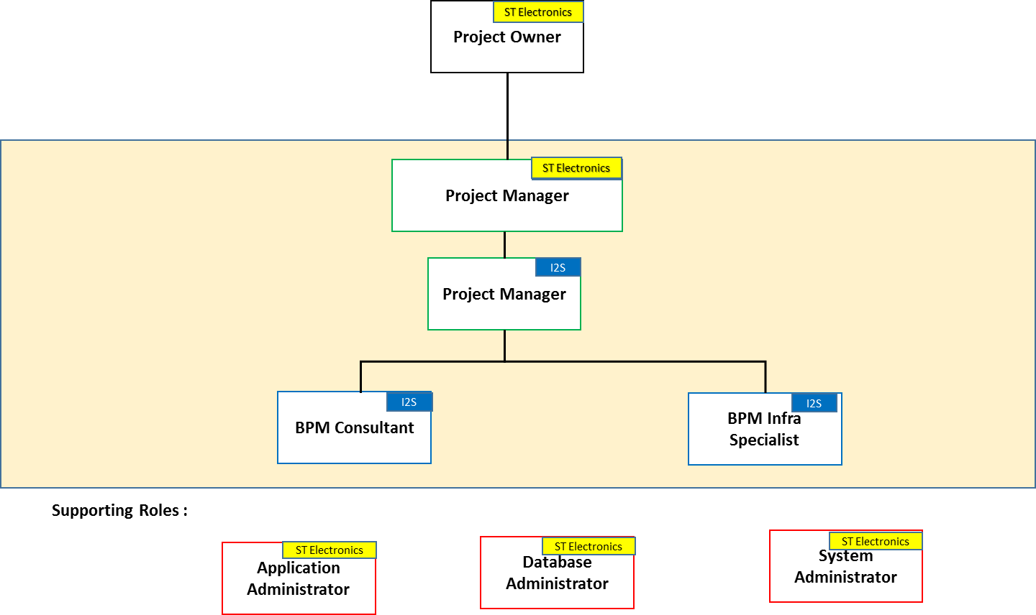

The supporting roles are illustrative and most of the customer responsibilities are outlined in the VF with greater clarity and detail.

* Application Owner – We need application owner details for each interfacing system and departments. This is to ensure they are informed and are accountable for the integration requirements.
* Application Administrator – i2s team will require access to the systems to perform testing.
* Database Administrator – This will involve providing access, creating scripts and performing day-day operational routine.
* System Administrator – This role involves providing logistics support to i2s team – Internet, Access to Floors, Conference Facility.

# 3.5. Assumptions and dependencies

* Functional SME Services will not be provided by i2s.
* We assume a lead-time of 2 weeks is provided before we start the project. This will be used for resource mobilization.
* Customer team will chair all governance meetings with the customer and i2s will support/participate in the meetings.
* We assume, we will be provided with 3 environments: Development, UAT and Production.
* I2s will be provided access to test Active Directory, SAP, PEOPLE SOFT, Databases and Web services systems.
* We assume users are willing to spend time to test the system. Users here refer to a stakeholder who understands the system end-end both from technical and operational perspective.
* Resources to perform Test data refreshes from production to test boxes will be provided by the customer.
* Requests for server logins, accounts and access to servers need to be completed before starting of any project. Any delays in this will have an impact on project start date.
* The onsite resources from i2s will be given the adequate working infrastructure (for example, desks, desk phone and required software) for performing their activities.
* All the necessary sign offs will happen within 10 days of the artefact submission and completion of the milestone
* i2s shall be only performing installation on DEV,UAT and PROD and all relevant sizing of hardware and HA solution will not be i2s responsibility.

# 3.6. Payment Terms (Services)

The costs are all inclusive

|  |  |  |
| --- | --- | --- |
| .**Milestone** | **Percentage** | **Amount in SGD** |
| Contract Sign Off | 15% |  |
| Installation (DEV,UAT and PROD) | 30% |  |
| SIT Sign Off | 20% |  |
| UAT Sign Off | 15% |  |
| Prod Sign Off | 10% |  |
| Post Go Live Support Completion | 10% |  |